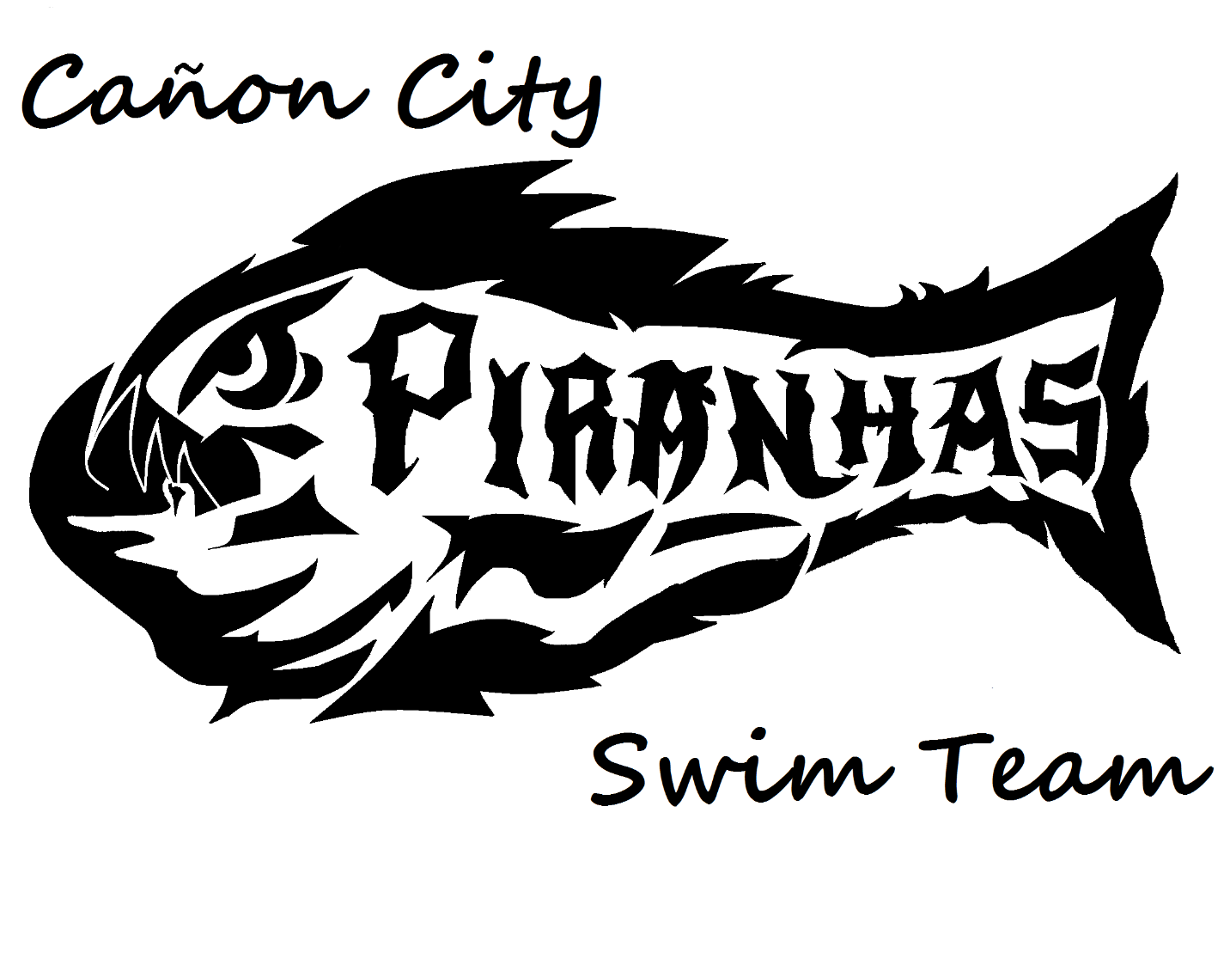
Piranhas
Handbook

WELCOME!!!
The Canon City Swim Team would like to welcome you to our team. We say “our” because that is exactly what it is. We are a parent-run organization and our successes depend on parent and family participation in all aspects of the team. Whether you are new to the world of competitive swimming or you have been swimming for years, we hope the information in this packet is useful. If you have any questions or concerns, feel free to contact a Coach or Board Member and we’ll be happy to assist. We are looking forward to a great swim season!!!
COACHES:
Head Coach: Aimee Bond
Assistant Coach: Jurhree Hill
BOARD MEMBERS: The administrative functions of the club are overseen by the Board of Directors. The board consists of (4) “Executive” positions as well as regular members of up to 8 additional members. The elections for board positions are held annually at the end-of-the-season party. Each Executive board member is assigned a specific responsibility. Our current board members are:
- President – Jurhree Hill
- Vice President– Melissa Smeins
- Treasurer– Brittney Willyard
- Secretary/parent liaison – Lauren Wieczorek
- Board Member/Swim shop – Danetta Gherna
What is the Canon City Swim Team?
The Canon City Swim Team Incorporated is also known as the Canon City Piranhas. We are a seasonal swim team that participates in the Southeast Colorado Aquatic League (SECAL). We participate in swim meets all along the Highway 50 corridor and for the first time, all the way to the San Luis Valley for a meet in Alamosa. We provide a guided age group program for children ages 6-18, however it is required that participants must be able to swim 25 yards.
Our Mission:
“To create fun, competitive swimming opportunities in a supportive environment, while encouraging good sportsmanship and family involvement.”
Costs Associated with Competitive Swimming:
Team Fees: As with any sport, there are expenses that must be absorbed by the organization such as paying the coach’s wages. Coaches are not parent volunteers. Some of the other costs include regular meet fees, pool usage fees paid the Recreation District and equipment.
Insurance: It is required that all swimmers have a current USA Swimming membership. This membership provides very important accident and medical insurance for every swimmer and every team. Each swimmer is covered at any organized practice and every competition that is USA Swimming sanctioned.
Gear: Team swimsuits are suggested but not required. (Although it is nice to look uniform as a team.) The cost can range anywhere from $40 - $60 depending on the style chosen. If you choose not to get a team suit, please purchase a high-quality suit at a reputable sporting goods store. Unfortunately, the cheaper Wal-Mart or Target suits will not hold up with high use. Practice suits should be purchased to wear for practices, so the team suit can be saved for meets. In addition to suits, swimmers should have properly fitting goggles (a spare pair is handy) and may want to wear a swim cap.
FEES for 2020
$37 USA SWIMMING membership (non-refundable, due prior to getting in the pool)
$200 Team Fees ($100 due once swimmer passes the swim test and prior to starting practice (non-refundable), remaining $100 due by June 14th.
Team Fee is discounted for families with multiple swimmers – 1st swimmer $200, 2nd swimmer $175, 3rd swimmer $125, 4th swimmer $100; any additional children after the fourth child will also pay $100.
SWIMMER RESPONSIBILITIES:
- A swimmer has responsibilities to the Team, the coach, parents and most importantly to themselves.
- Swimmers need to prepare themselves for 100% effort each time they come to practice.
- Swimmers need to come prepared to practice with all required equipment.
- At all practices, meets or social gatherings, swimmers will behave in such a way that their actions reflect positively on the team.
- Swimmers will be respectful:
  - Of the coaches, by listening to them while they are talking. Show active listening. Respond to coaching with a good attitude and your best efforts! No complaining! Show up early so you are ready to swim when practice starts.
  - Of your teammates by not interfering with them during practice. Stay focused and avoid horseplay.
  - Of yourself by working hard in practice to get better. Reward yourself for all your hard work by becoming a better swimmer.
  - Of your team by “pitching in” to help set up and tear down the pool before and after practice. The more that help, the quicker it gets done.
PARENT RESPONSIBILITIES:
- There must be understanding and cooperation among parents, swimmers and coaches.
- Remember the coach is the coach. Allow them to do the job, which includes running practices and choosing events for your swimmer at meets. Sometimes your swimmer may not want to enter the Butterfly event, but it will help them grow as an all-around swimmer.
- As always, if you have a concern, problem, or complaint (or even praise!) please contact the coach directly.
- Please encourage your child to work hard at practice and pile on the praise for their hard work and efforts.
- Please be patient with your swimmers. (Especially those 10 and under). There may be a time when your swimmers times are not as fast as they were and that’s okay. Stroke technique, growth, and strength may all be factors. We want our swimmers to be successful; however, that can also mean having fun, getting exercise, and making new friends!
- Parents should help encourage proper nutrition and eating habits. Sending your swimmer to practice at 6am with a donut and Starbucks will not result in good performance.
COACHES RESPONSIBILITIES:
- The coaches’ job is to supervise the swim team. The coaches are helping the swimmers improve themselves and be the best version of themselves they can be.
- The coaches are responsible for placing youth in practice groups that are based on age and ability level of that individual.
- Stroke instruction and training regimen are the responsibility of the coaches.
- Coaches will make the decisions concerning which events swimmers should enter in competition.
- Coaching staff will conduct and supervise warm-up procedures for the team during meets.
- Coaches will ensure that all swimmers are adhering to safety guidelines at all times.
- After each race, the coaches will offer only constructive criticism and positive reinforcements regarding the swimmers’ performance.
- The building of a relay team is the responsibility of the coaches.
WHAT TO EXPECT AT A SWIM MEET?
- Arrive at the pool at least 15 minutes prior to the scheduled warm-up time.
- Expect to volunteer to support the meet in some way. If you are not an Official or working toward becoming an official, you will be required to share timing duties with other members of the team. Timing trainings will be held near the start of the season.
- Verify the swimmer’s event number, heat number and stroke by using the Meet Program (available for purchase at each meet for $5). Document these on the swimmer’s forearm with a Sharpie marker.
- Events are held in all 4 of the competitive strokes (Freestyle, Breast, Back and Butterfly) with varying distances depending on the age group of the swimmer.
- Meets are held nearly every weekend, however it is not mandatory to attend meets.
- What to bring?
  - Competition suit, goggles, swim cap, towel, healthy snacks, plenty of water or other sports drinks, Sharpie marker, highlighter, a camp chair, clothes to change into, and sunscreen (if we are outside).
MEET SCHEDULE (Proposed, reduced due to COVID)
June 11th-13th Salida
June 18th-20th Lamar
June 25th-27th Las Animas
July 2nd-4th No meet- break for holiday
July 9th-11th Canon City
July 23rd-25th La Junta
July 30th-Aug 1st – League- Co-hosted by Alamosa and Pueblo West in Rocky Ford
Aug 6th - Aug 8th State Championships in Lamar, hosted by both Las Animas and Lamar

PHOTOGRAPHY CONSENT FORM
The Canon City Piranhas Swim Team may wish to take photographs (individuals and groups) of swimmers at meets and club events. All photos will be in good taste. The club requires parental consent to take and share photographs via e-mail, prints or social media. Parents have the right to refuse agreement to their child being photographed.
“As the parent/caregiver of ______________________, I allow the following
Take photographs to include with newspaper articles
_________ Consent Given ______________Consent refused
Take photographs to be posted on social media
__________Consent Given ______________Consent refused
Take photographs as a team to be used in promotions and thank you notes to our sponsors
__________Consent Given _______________Consent refused

Signed:_______________________________________ Date:____________________

ELECTRONIC COMMUNICATION POLICY
The Canon City Piranhas Swim Team recognizes the prevalence of electronic communication and social media in today’s world. Many of our swimmers use these means as their primary method of communications. While we acknowledge the value of these methods of communication, we also realize that there are associated risks that must be considered when adults use the methods to communicate with minors.
All communications between a coach or other adult and an athlete must be professional in nature and for the purpose of communicating information about team activities. The content and intent of all electronic communications must adhere to the USA Swimming Code of Conduct regarding Athlete Protection.
For example, as with any communications with an athlete, electronic communications should not contain or relate to any of the following:
- Drugs or alcohol use, inappropriate or sexually explicit pictures
- Sexually oriented conversation; sexually explicit language; sexual activity
- The adult’s personal life, social activities, relationship or family issues, or personal problems; and
- NOTE: Any communication concerning an athlete’s personal life, social activities, relationship or family issues or personal problems must be transparent, accessible and professional.
  - Transparent – All electronic communication between coaches and athletes should be transparent. Your communication should not only be clear and direct, but also free of hidden meanings, innuendo and expectations.
  - Accessible – All electronic communication between coaches and athletes should be considered a matter of record and part of the Club’s records. Whenever possible, include another coach or parent in the communication so that there is no question regarding accessibility.
  - Professional: All electronic communication between a coach and athlete should be conducted professionally as a representative of the Club. This includes word choices, tone, grammar, and subject matter that model the standards and integrity of a staff member.
- FACEBOOK, TWITTER, INSTAGRAM, ETC.
  - Coaches may have personal social media pages but they are not permitted to have any athlete member of the Club join their personal page as a “friend”. A coach should not accept any “friend” request from an athlete. In addition, the coach should remind the athlete that this is not permitted. Coaches and athletes are not permitted to “private message or instant message” each other through these sites.
  - The Canon City Swim Team has an official Facebook page that athletes and parents can “friend” and follow for information and updates on team-related matters.
- TEXT MESSAGES
  - Subject to the Transparent/Accessible/Professional guidelines and be used only to communicate information directly related to team activities.
- EMAIL
  - Subject to the Transparent/Accessible/Professional guidelines and should be copied to another coach, parent or board member.

SWIM OFFICIALS NEEDED!
As a Seasonal Swim Team, we are required to provide Swim Officials at all League swim meets.
It’s a fun way to become involved with the team and at meets! You’ll learn all the requirements for the competitive strokes and what is/isn’t allowed.
This service is needed at EVERY meet and if there aren’t enough swim officials present, the meet isn’t “Official”! So if one of our swimmer’s gets a State Qualifying time and the meet isn’t “official” their times don’t count. ☹
There is no cost to you to become an official. Your background check, training and USA Swimming membership is covered by the Team.
If you would like to become an Official, please talk to any Board Member and they will give you the information.

*******************JOIN US!!!***********************

